## A brief description of the networking setup provided

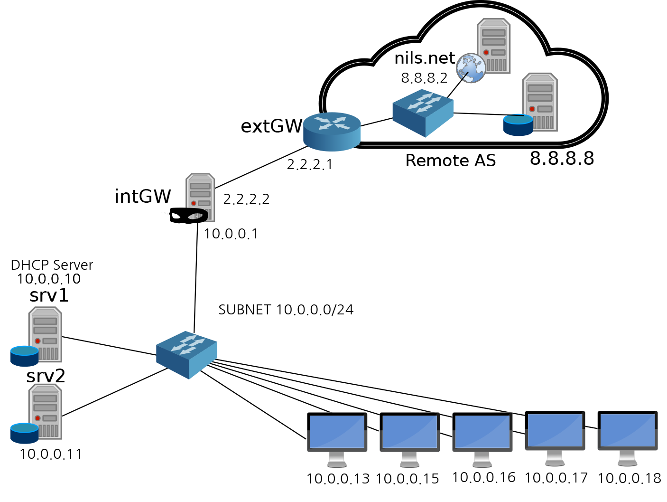

In order to reach 8.8.8.8, I had to fix “option routers 10.0.0.111” in dhcpd.conf to “option routers 10.0.0.1”. This enabled the request to 8.8.8.8 to be processed appropriately.

## Why can you resolve nils.net?

DHCP server at 10.0.0.10 assigns an IP together with its default DNS server. Using the provided default DNS server from 10.0.0.10 (DHCP server), you can resolve the IP address sof nils.net. The IP address of nils.net is 8.8.8.2.

## Who is doing the NAT’ing? Which address ranges it is translating between?

intGW at 10.0.0.1 is doing Network Address Translation (NAT). The address ranges it is translating between is 10.0.0.0/24

## Did you manage to block srv1 from reaching the outside world?

I managed to block srv1 from reaching the outside world by making new policies at iptables of intGW at 10.0.0.1. With policies, intGW blocked all traffics from and to 10.0.10, srv1.

## Did you do any of the additional tasks?

I did attempt to increase the number of desktops but did not succeed.